# Validation – using a Lookup table

Create a new table called *tblGenre* in design view

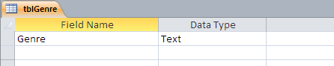



Then, change to worksheet view and enter up the music genres.

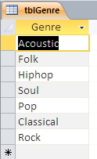

# Create tblCollection with these fields

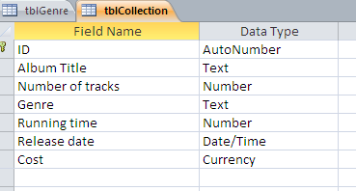

# Set up the lookup table for the Genre field

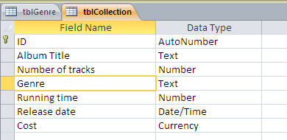

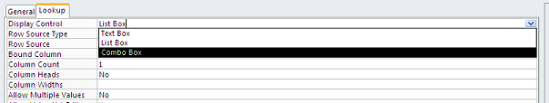

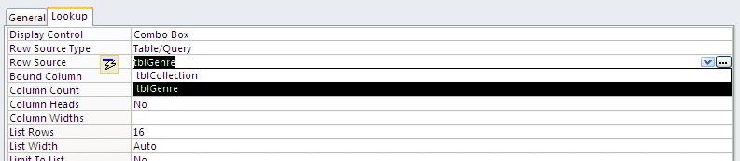

# Enter the data using the lookup field

